REGULATOR 7805
Voltage sources in a circuit may have fluctuations resulting in not providing fixed voltage outputs. A voltage regulator IC maintains the output voltage at a constant value. 7805 IC, a member of 78xx series of fixed linear voltage regulators used to maintain such fluctuations, is a popular voltage regulator integrated circuit (IC). The xx in 78xx indicates the output voltage it provides. 7805 IC provides +5 volts regulated power supply with provisions to add a heat sink.
All voltage sources cannot able to give fixed output due to fluctuations in the circuit. For getting constant and steady output, the voltage regulators are implemented. The integrated circuits which are used for the regulation of voltage are termed as voltage regulator ICs. Here, we can discuss about IC 7805.The voltage regulator IC 7805 is actually a member of 78xx series of voltage regulator ICs. It is a fixed linear voltage regulator. The xx present in 78xx represents the value of the fixed output voltage that the particular IC provides. For 7805 IC, it is +5V DC regulated power supply. This regulator IC also adds a provision for a heat sink. The input voltage to this voltage regulator can be up to 35V, and this IC can give a constant 5V for any value of input less than or equal to 35V which is the threshold limit.
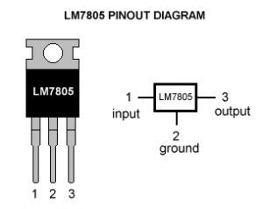

7805 IC Rating
- Input voltage range 7V- 35V
- Current rating I_{c =} 1A
- Output voltage range V_{Max=5.2V ,}V_{Min=4.8V}

Regulated Power Supply Circuit
- The voltage regulator 7805 and the other components are arranged in the circuit as shown in figure. 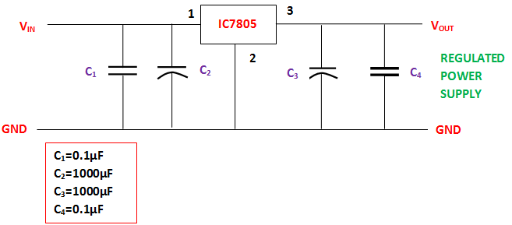

The purposes of coupling the components to the IC7805 are explained below. C₁- It is the bypass capacitor, used to bypass very small extent spikes to the earth. C₂ and C₃- They are the filter capacitors. C₂ is used to make the slow changes in the input voltage given to the circuit to the steady form. C₃ is used to make the slow changes in the output voltage from the regulator in the circuit to the steady form. When the value of these capacitors increases, stabilization is enlarged. But these capacitors single-handedly are unable to filter the very minute changes in the input and output voltages. C₄- like C₁, it is also a bypass capacitor, used to bypass very small extent spikes to the ground or earth. This is done without influencing other components.

Applications of Voltage Regulator 7805 IC
- Current regulator
- Regulated dual supply
- Building circuits for Phone charger, UPS power supply circuits, portable CD player etc
- Fixed output regulator
- Adjustable output regulator etc.

